Jason Santiago

CET-2793C  
Dr. Roberts  
November 30, 2024  
  
  
  
  
***Group Policies***

1. Do not allow the user to load a program (install or run an .exe)  
   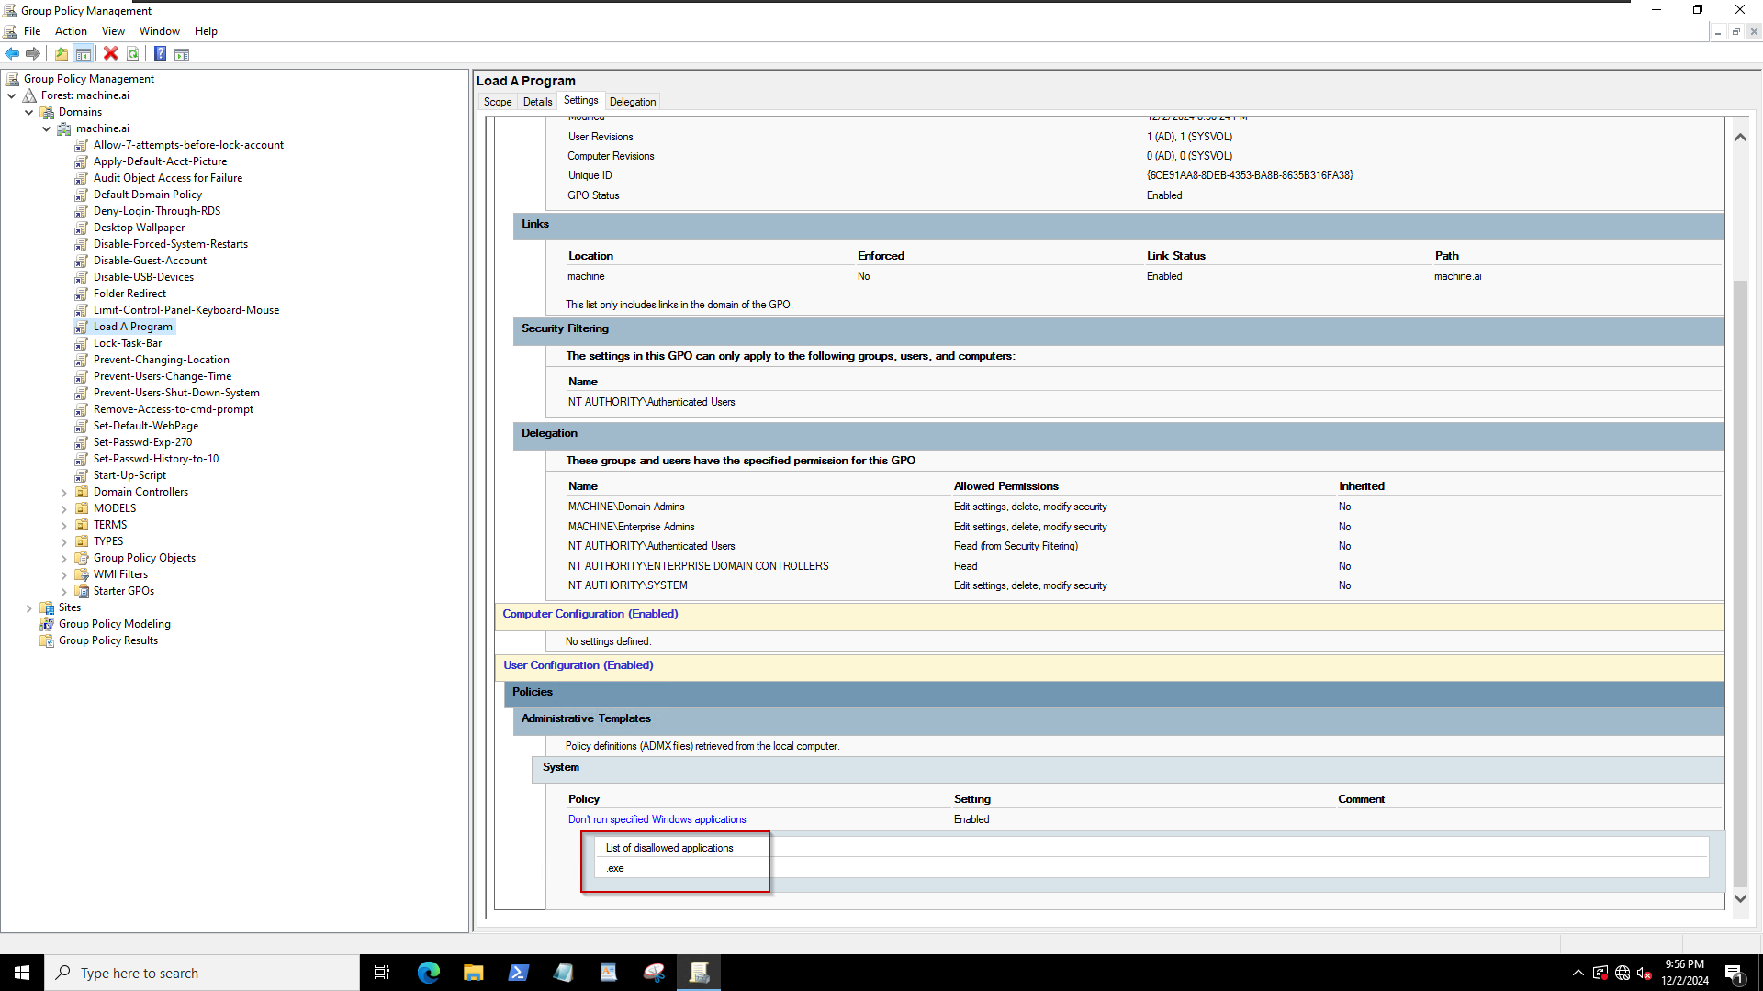
2. Disable the guest account  
   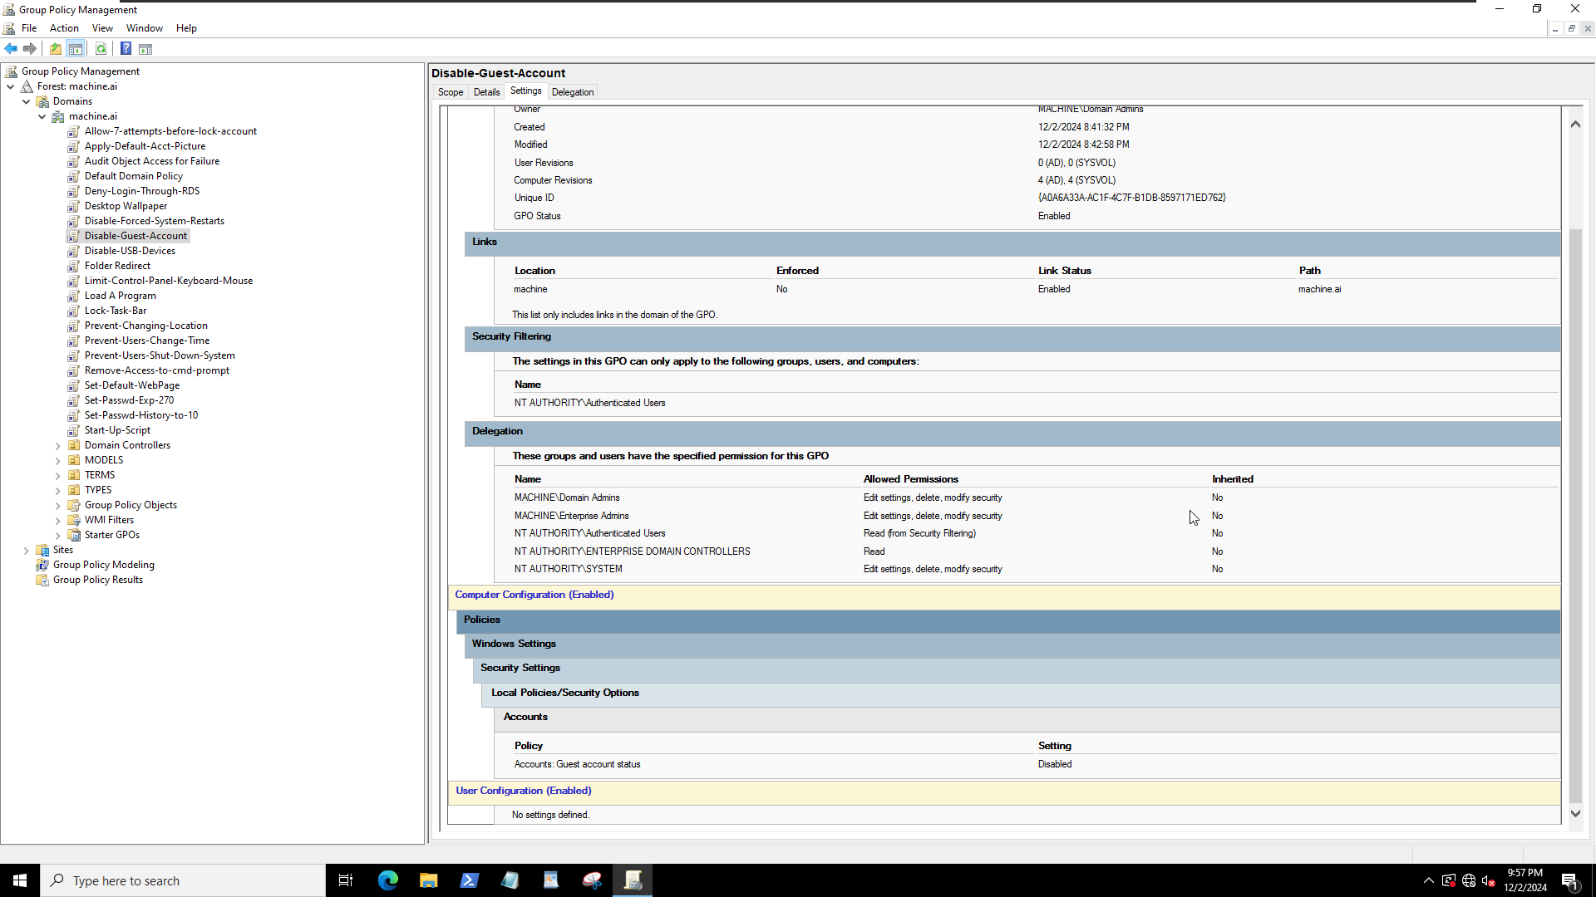
3. Disable forced system restarts  
   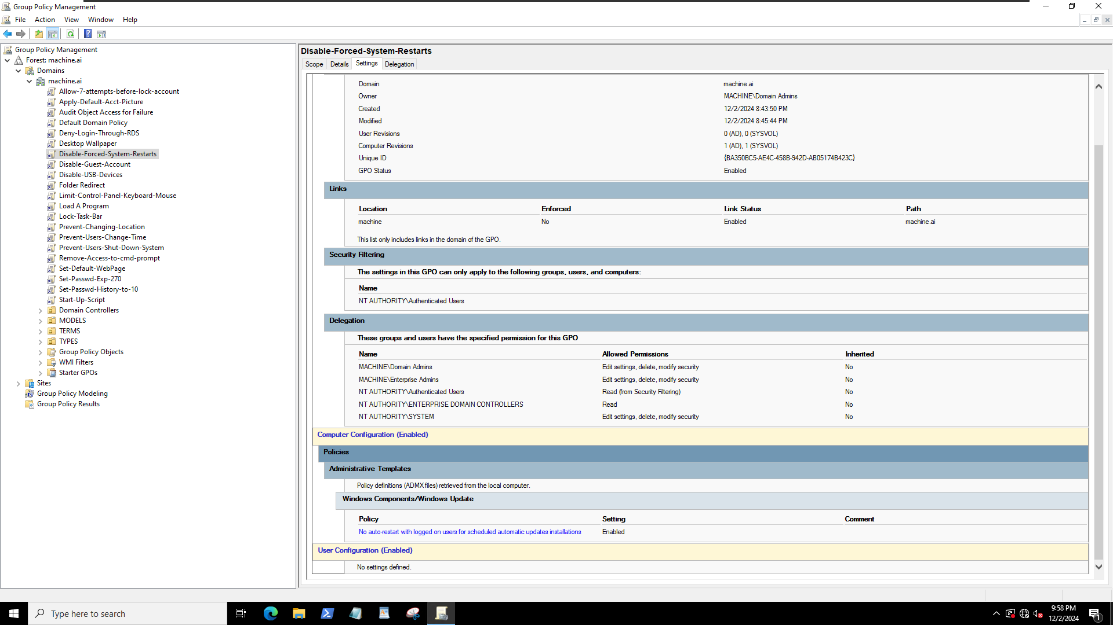
4. Prevent users from changing the time, though allow them to view the calendar  
   A computer screen shot of a computer screen

   Description automatically generated
5. Set password expiration to 270 days  
   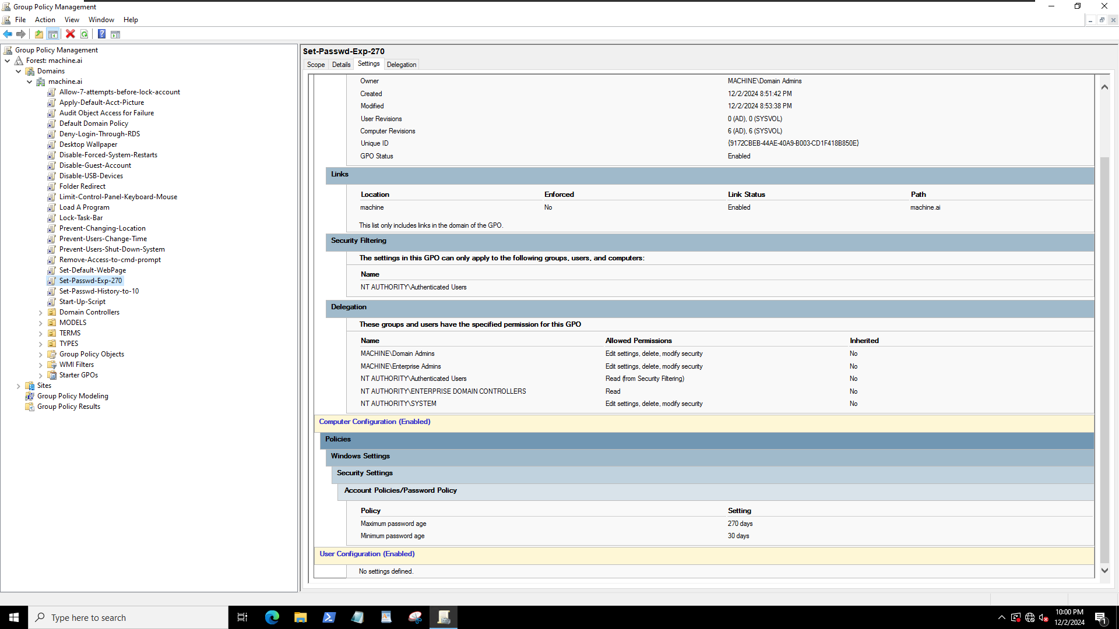
6. Allow users seven attempts before locking their account  
   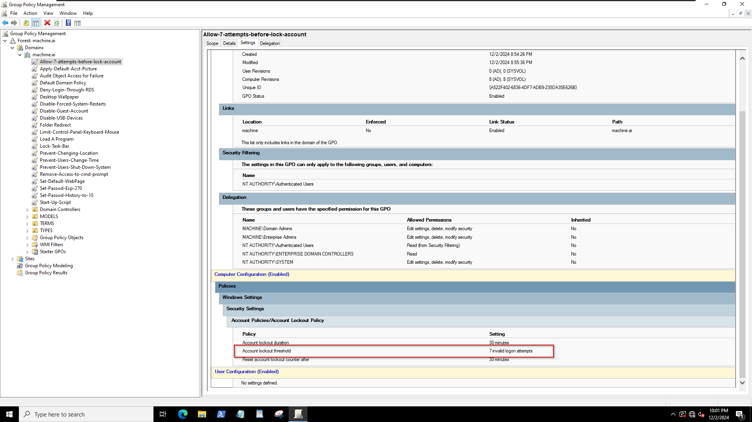
7. Allow user access to keyboard and mouse but no other control panel application  
   A screenshot of a computer

   Description automatically generated
8. Do not allow users to shut down the system  
   A screenshot of a computer

   Description automatically generated
9. Remove the ability to use the command prompt  
   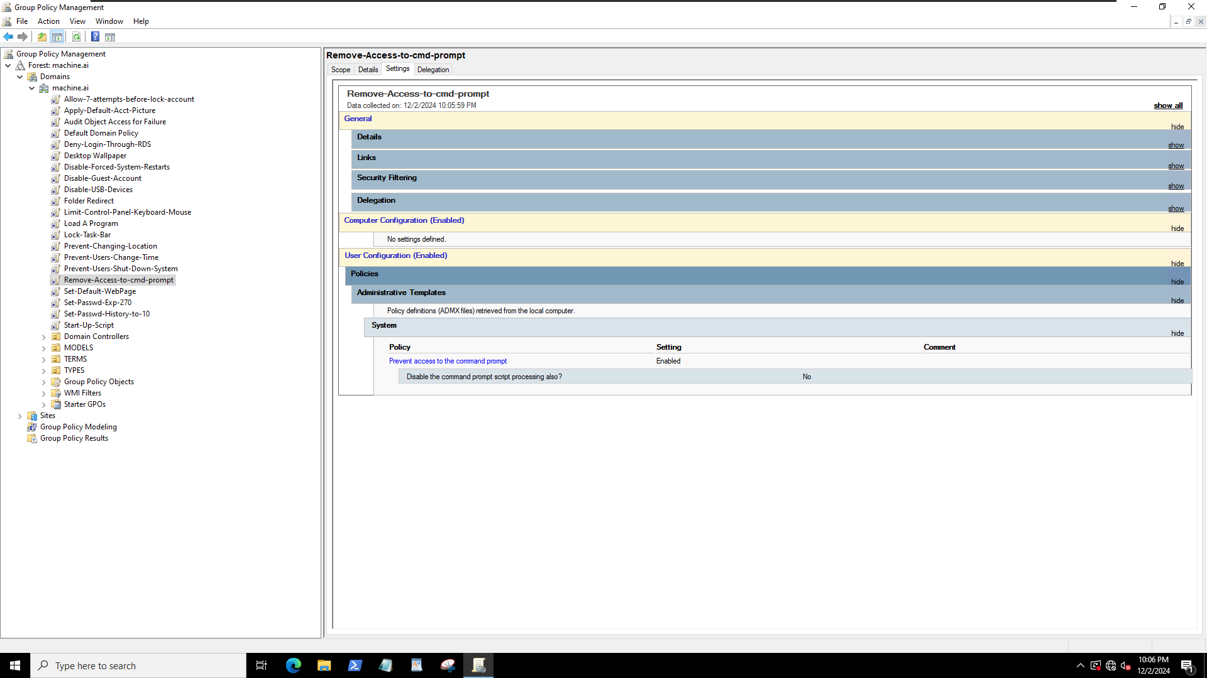
10. Change the default background of all computers to Light Purple (rgb(212, 142, 207))
    1. [you MUST use the set wallpaper policy for this one to work correctly]  
       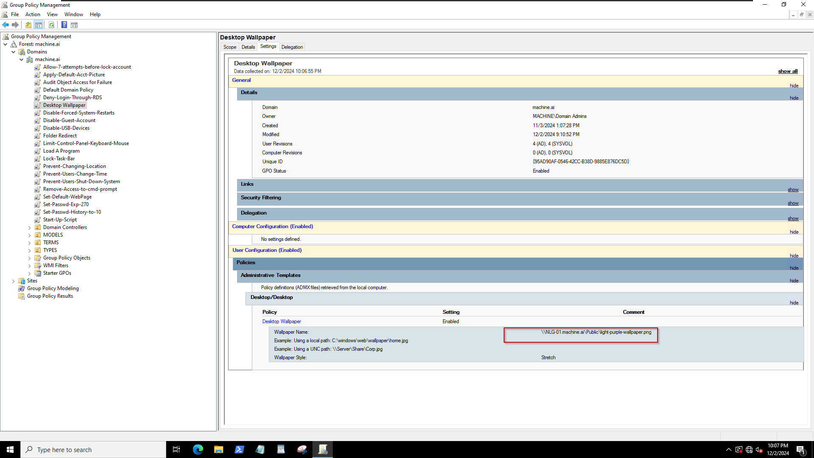
11. Disable USB devices  
    A screenshot of a computer

    Description automatically generated
12. Apply the default account picture to all users  
    A screenshot of a computer

    Description automatically generated
13. Create a startup script that deletes the contents of the "%LocalAppData%\Microsoft\Edge\User Data\Default\cookies" folder on shutdown  
    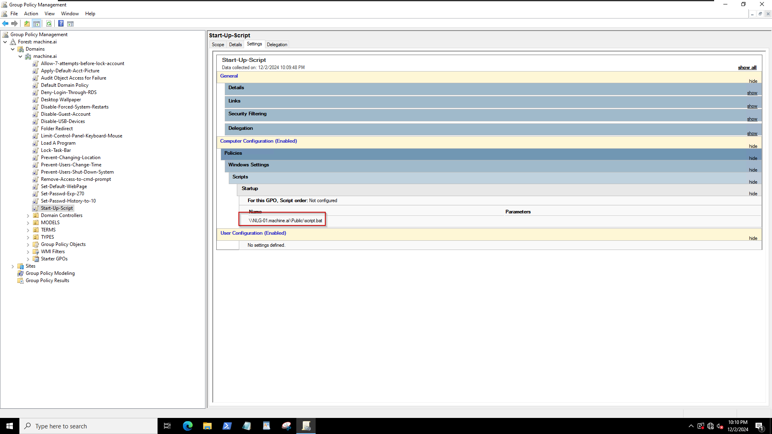
14. Set password history to 10  
    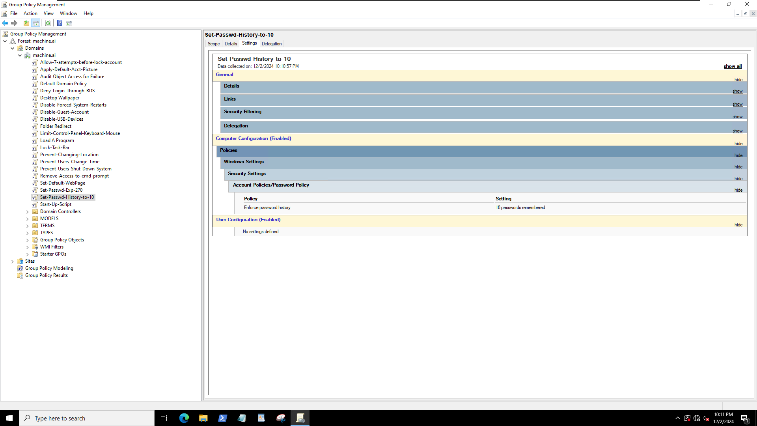
15. Set the default webpage to [https://thehackernews.com/Links to an external site.](https://thehackernews.com/)  
    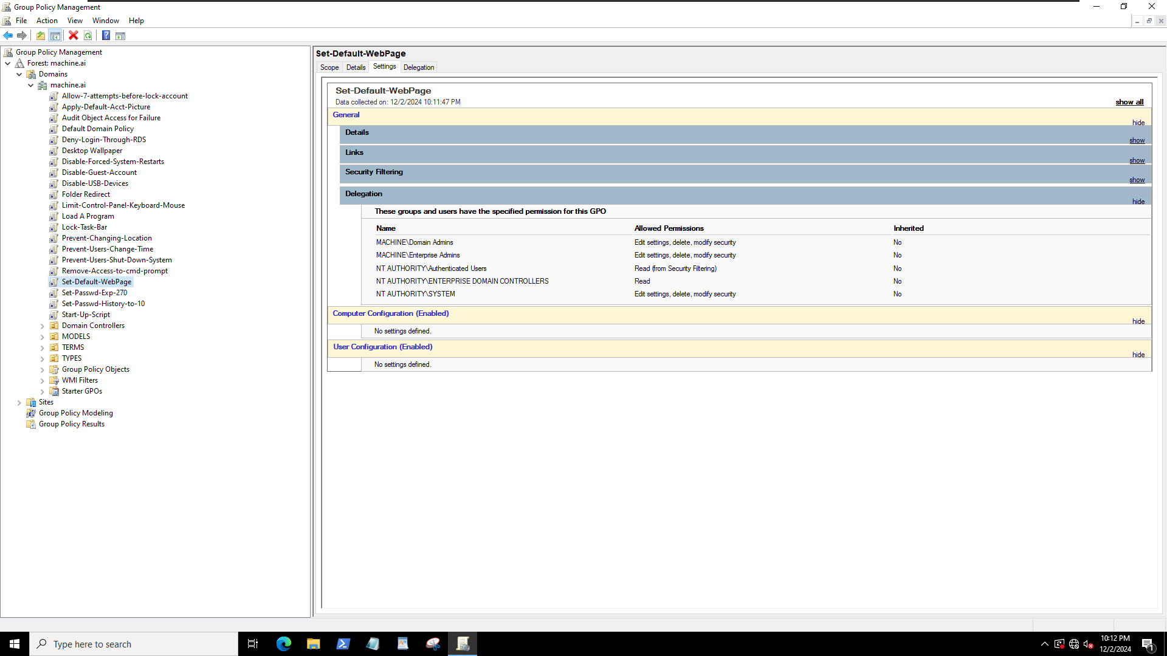
16. Lock the taskbar so users cannot change its location  
    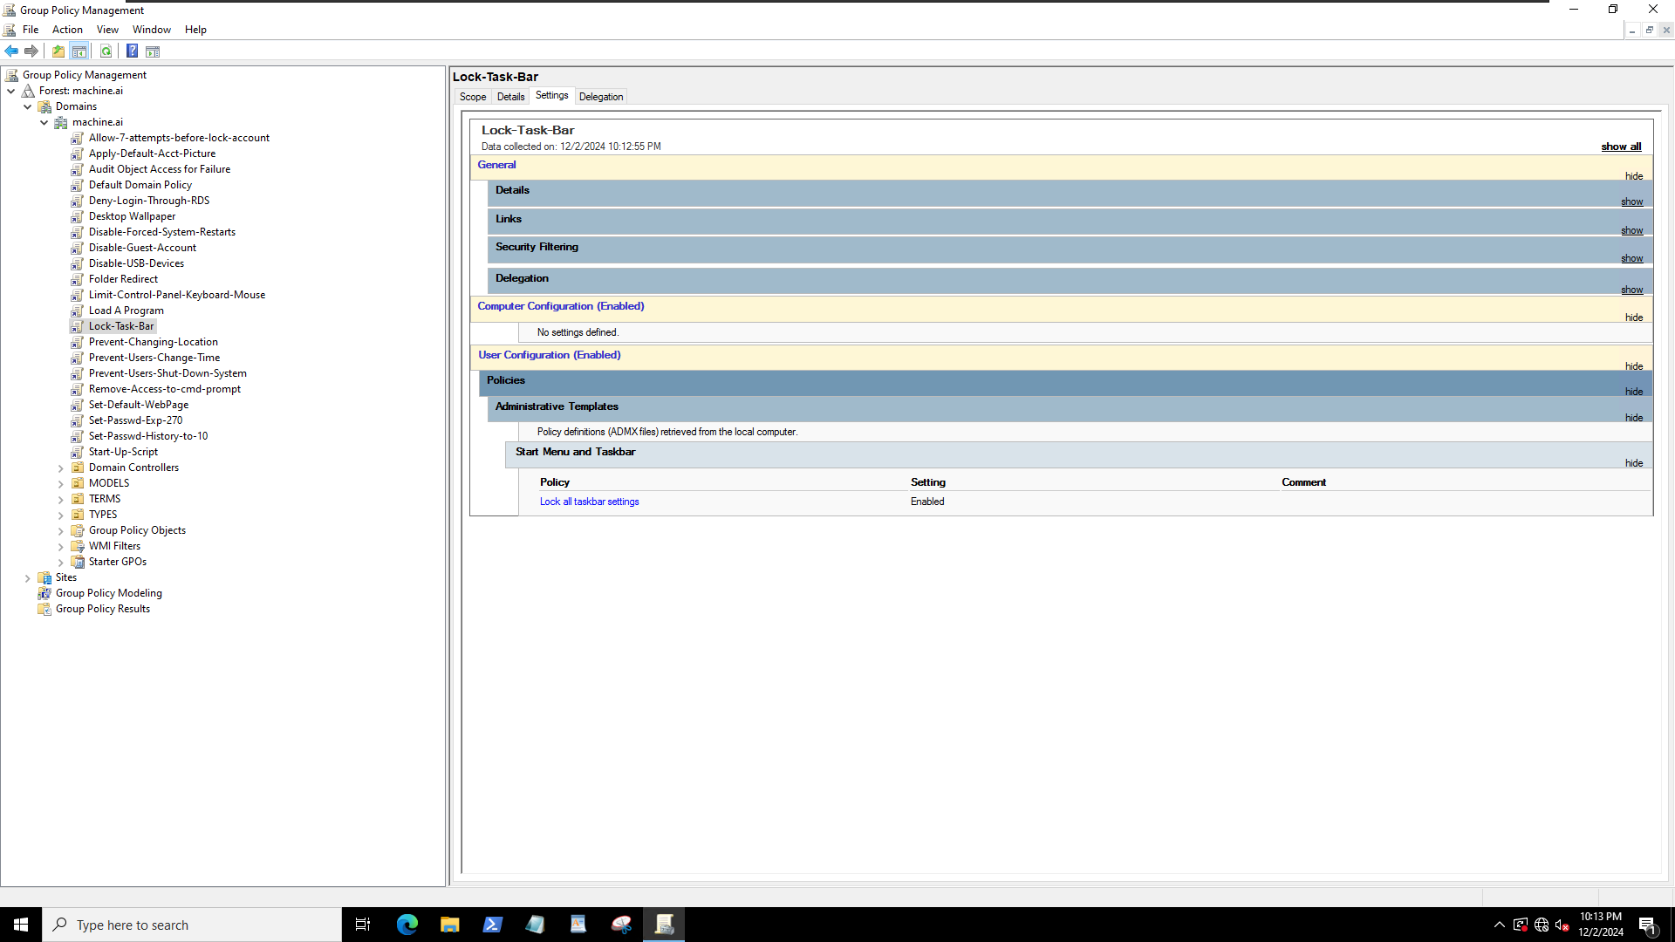
17. Audit object Access for Failure  
    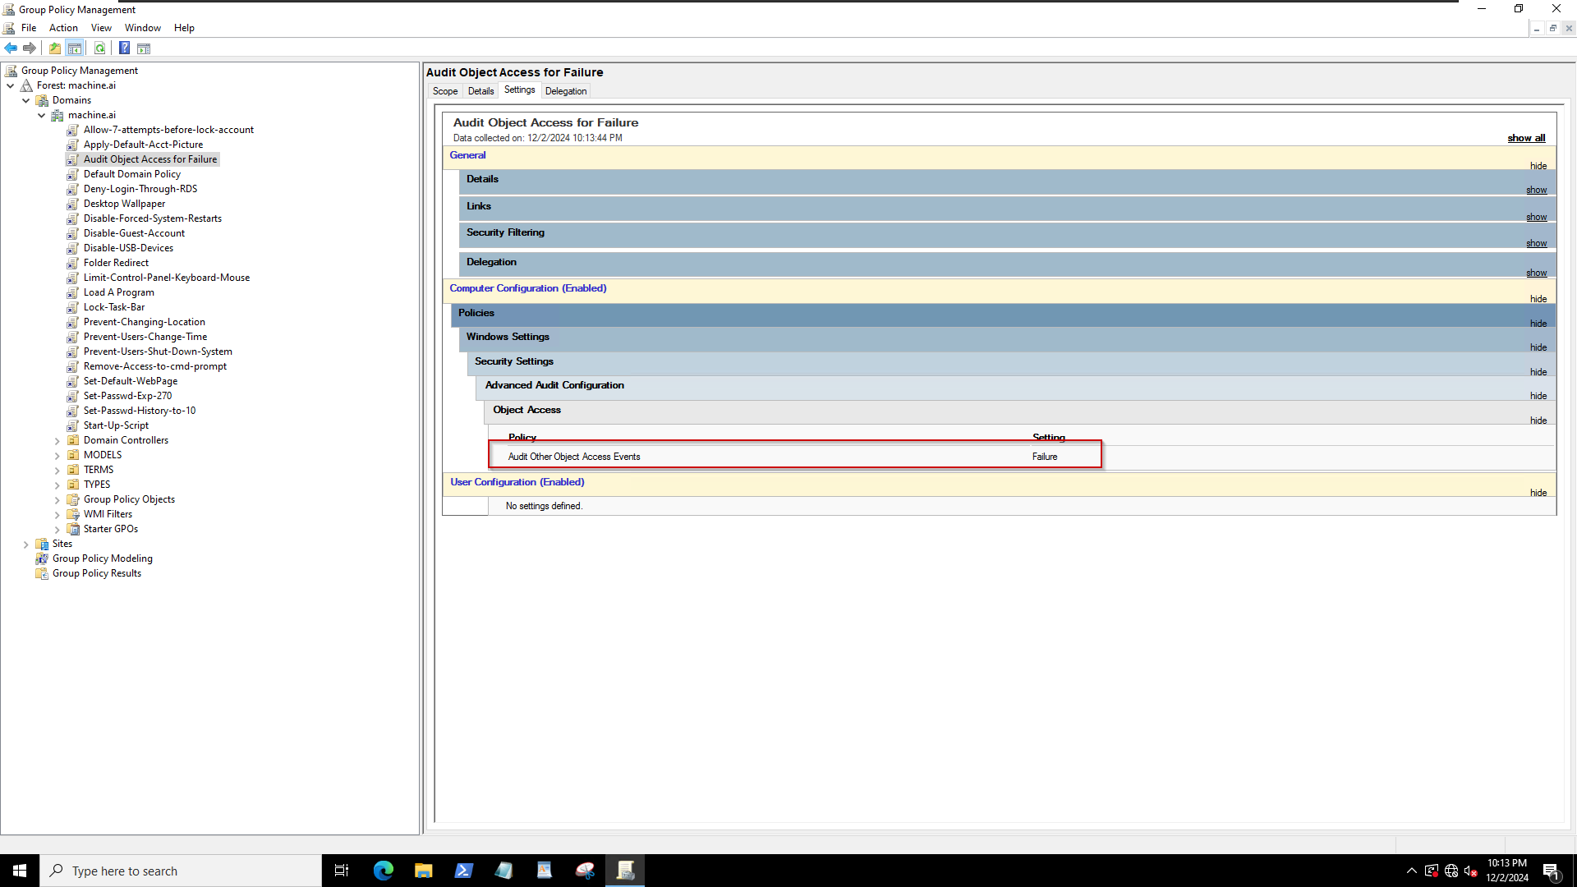
18. Redirect the documents folder to the File server [from previous assignment]  
    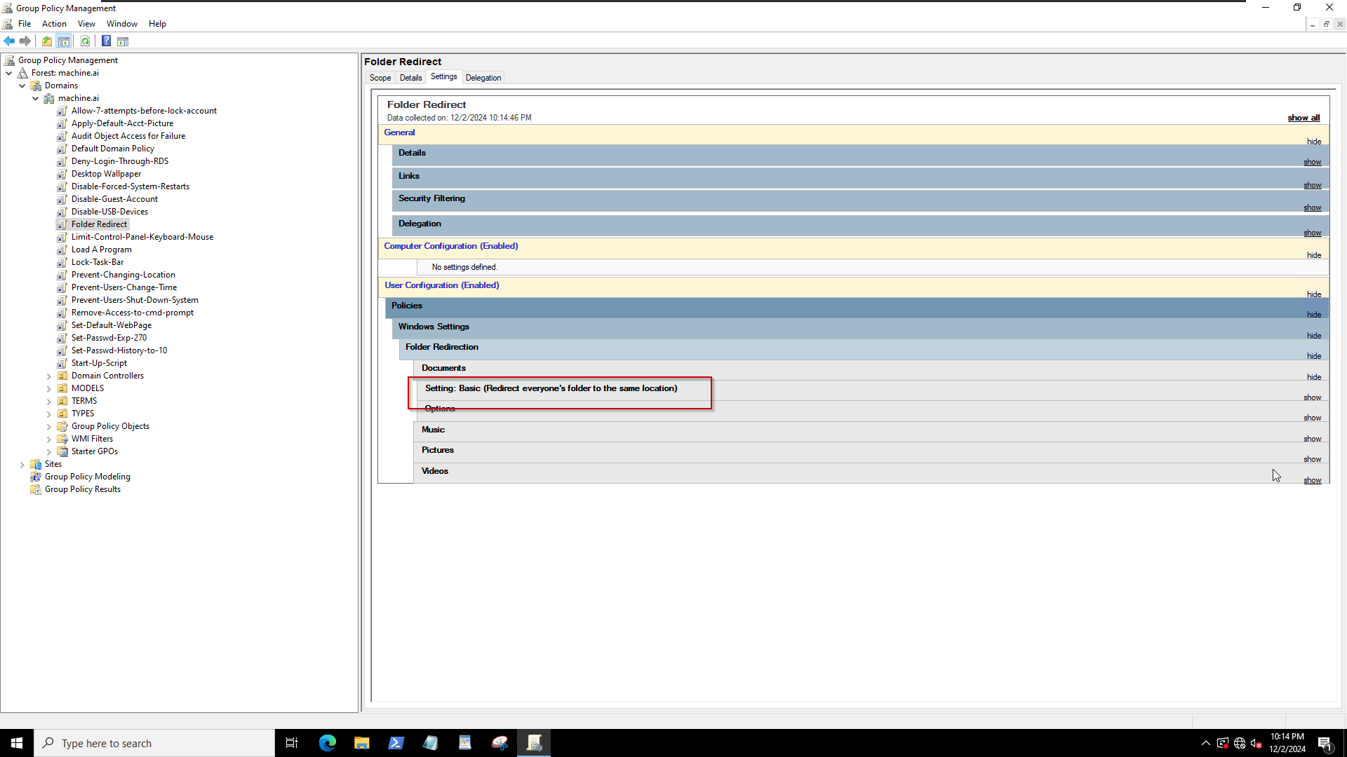
19. Deny log on through remote desktop services (RDS)  
    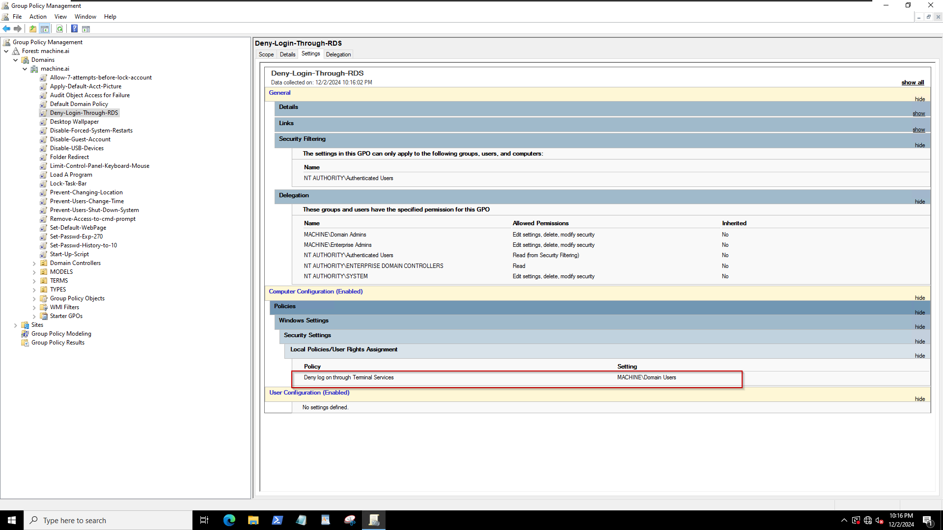
20. Prevent users from changing their geographic location  
    A screenshot of a computer

    Description automatically generated

======================( Proof of GPO settings below )=====================  
Log in to the client machine (~~NewOrleans~~) as a domain user.  
*- AIML = The client machine for the `machine.ai` domain. The metro.entertainment domain failed due to vmware circumstances so I resorted to the previous domain. “machine.ai”*

Below is the image of guest account disabled

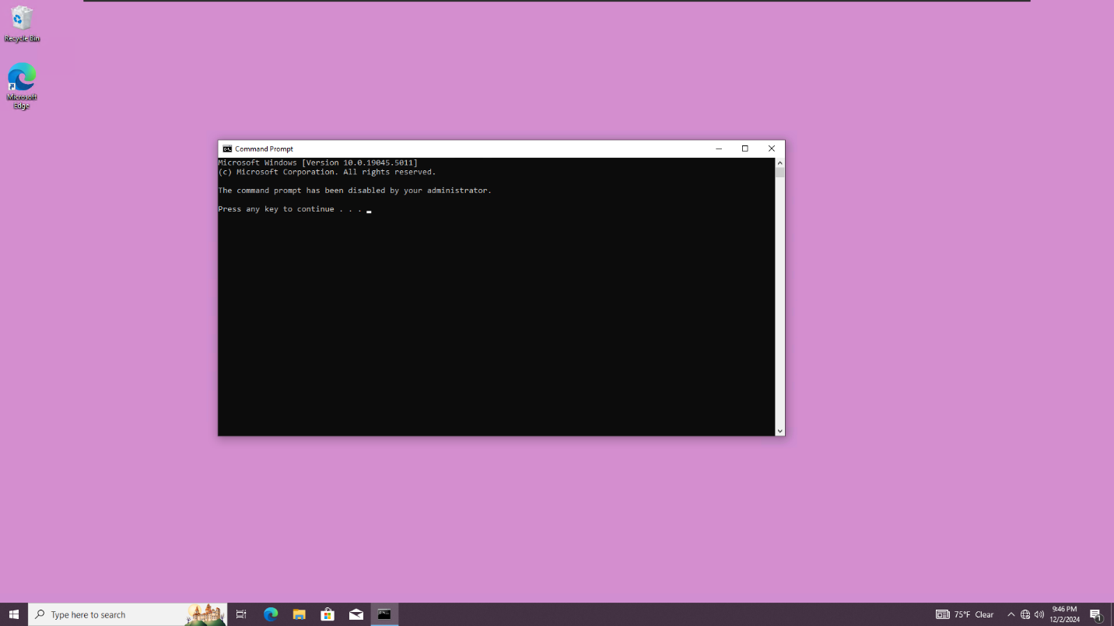  
Above is the image showing disabled command prompt.